Case 10-AM,S-Peru-Moche-Jaguar Shaman on Gooseback-Ceramic-100-700 CE

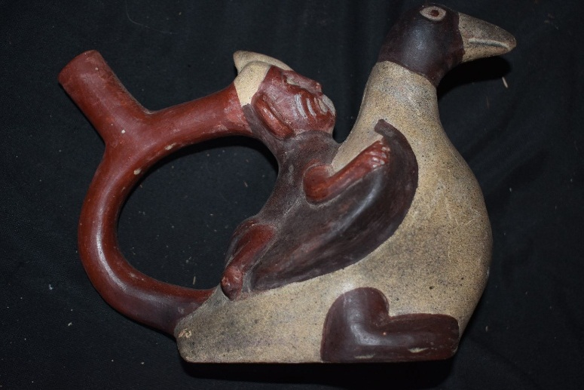 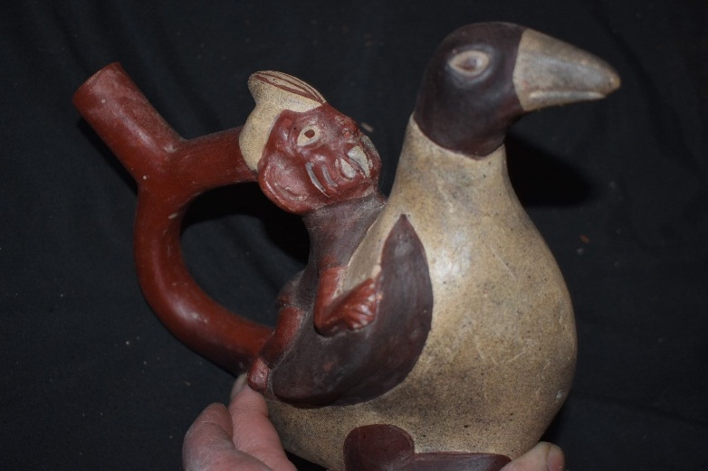

Figs. 1-2. Moche-Jaguar Shaman as the Fanged Deity on supernatural Goose-Ceramic-100-700 CE **Formal Label:** Peru-Moche-Jaguar Shaman as the Fanged Deity on supernatural Goose-Ceramic-100-700 CE

**Display Description:**

This vessel is thought to have been used in ceremonies in which the shaman or his acolytes would assume the spiritual being of the supernatural jaguar. The shaman wears the emblematic mask of the Fanged Deity or Decapitator, the supernatural jaguar. In the Moche culture there was only one deity, a master jaguar, who is the master of the spirit world and the patron deity of shamans. This deity reigned over western South America for at least 2000 years and still survives today.

The jaguar shaman looks upwards exhorting his avian protector spirit. The body of the vessel is an avian spirit helper in the form of a goose ascending the sky, which is characteristic of shamanic flight. Flight associates this shaman with entheogen use and associates him with the ritual of spiritual transformation, death and resurrection (Borhegyi 2010). In Moche culture we see mushrooms and their symbols associated with Lords and the higher theocracy. The Lord of Sipán does not have mushrooms overtly growing out of his head, but mushroom related symbolism is overwhelming, through his mushroom headdress, tumi, and symbols on his clothes, and ornaments with mushrooms. For instance, this Moche shaman has transfixed eyes indicative of a trance state.

Moche shamanism had standard methods of depicting the shaman, which were not unique. Chavin, Paracas, Nazca and Tiahuanaco-Huari cultures all display an essentially similar iconography. Headdresses with fanged jaguars impersonating the Fanged Deity (Benson 1972: 27) as in this example and heads with projecting mushrooms or with eyes in a transfixed state all point to the otherworldly experience of the Moche shaman.

**LC Classification: F3430.1.**

**Date or Time Horizon:** 400 BCE-600 CE

**Geographical Area:** North coastal Peru

**Map, GPS coordinates: -6.80139 -79.60202; 6º48'5" S 79º36'7.28" W.**

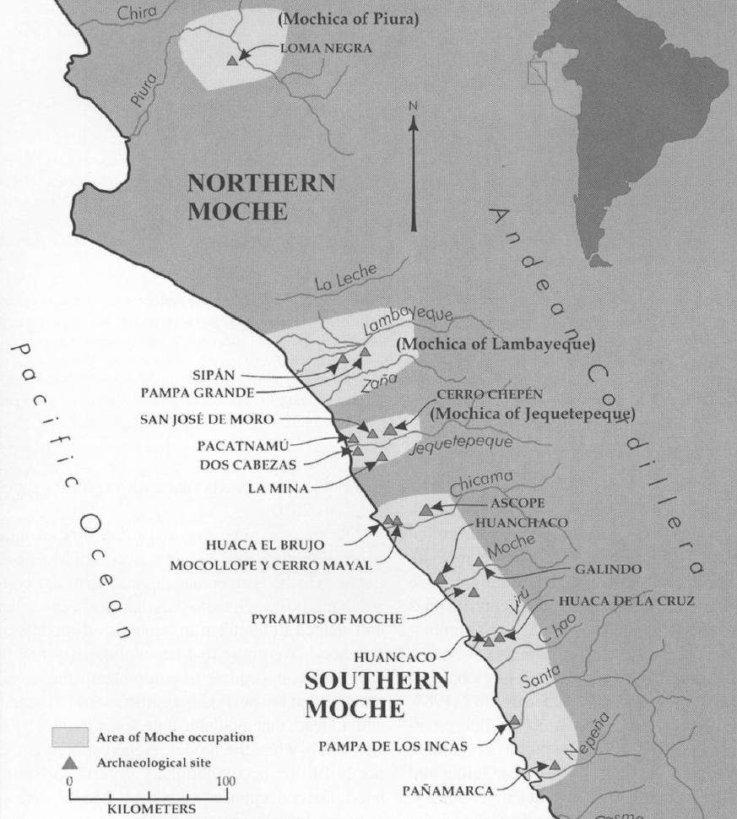

Fig. 6. Map of Moche regions as currently conceived and significant Moche sites. Map courtesy Moro Archaeological program.

**Cultural Affiliation:** Moche, Mochica

**Media:** clay; polychrome colors: red, cream, black, skin color

**Dimensions:** H mm; in

**Weight: gm; oz**

**Condition: original**

**Provenance:** unknown

**Discussion: (Attributed to Wiki)**

Huaca Rajada, near the village of Sipán in the Lambayeque valley, was excavated in 1987 uncovering the elaborate, jewelry-filled tomb of a Moche warrior-priest. Several more burial chambers containing the remains of Moche royalty were soon excavated, all dating from about 300 CE. In 1997 excavations at Dos Cabezas, a site inhabited from roughly 150 to 500 CE, revealed the first of three tombs containing the remains of three Moche elite. Each tomb was adjacent to a small compartment containing a miniature representation of the contents of the tomb, complete with a copper figure representing the dead man. The skeletal remains indicated that each of the men was 8 to 12 inches taller than the average Moche adult male and so represented an élite core of society that had access to more foodstuffs.

Moche society was agriculturally based, with a significant level of investment in the construction of a network of irrigation canals for the diversion of river water to supply their crops. Their culture was sophisticated; and their artifacts express their lives, with detailed scenes of hunting, fishing, fighting, sacrifice, sexual encounters and elaborate ceremonies. The Moche are particularly noted for their elaborately painted ceramics, gold work, monumental constructions ([huacas](https://en.wikipedia.org/wiki/Huaca" \o "Huaca)) and irrigation systems.[[2]](https://en.wikipedia.org/wiki/Moche_culture#cite_note-2)

Both iconography and the finds of human skeletons in ritual contexts seem to indicate that [human sacrifice](https://en.wikipedia.org/wiki/Human_sacrifice) played a significant part in Moche religious practices. These rites appear to have involved the elite as key actors in a spectacle of costumed participants, monumental settings and possibly the ritual consumption of blood. The [tumi](https://en.wikipedia.org/wiki/Tumi" \o "Tumi) was a crescent-shaped metal knife used in sacrifices. While some scholars, such as [Christopher B. Donnan](https://en.wikipedia.org/wiki/Christopher_B._Donnan) and [Izumi Shimada](https://en.wikipedia.org/wiki/Izumi_Shimada), argue that the sacrificial victims were the losers of ritual battles among local elites, others, such as [John Verano](https://en.wikipedia.org/wiki/John_Verano) and [Richard Sutter](https://en.wikipedia.org/w/index.php?title=Richard_Sutter&action=edit&redlink=1), suggest that the sacrificial victims were warriors captured in territorial battles between the Moche and other nearby societies. Excavations in plazas near Moche [huacas](https://en.wikipedia.org/wiki/Huacas" \o "Huacas) have found groups of people sacrificed together and the skeletons of young men deliberately [excarnated](https://en.wikipedia.org/wiki/Excarnation" \o "Excarnation), perhaps for temple displays.

**Provenance:**

Garcia Fernandez collected this ceramic while living in Peru 1950-1980.

**Discussion: (attributed to Wiki)**

Among the Moche, sickness is a supernatural attack from the other world of evil spirits, acting on their own or at the bequest of a shaman. The healing shaman divines the identity of the attacker and repels its malevolent power. All shamans have the power to heal and to harm, hence, they are both feared and respected in their communities. Healing is a group endeavor. Father Antonio de la Calancha, an Augustinian monk in Northern Peru wrote in 1638 that curers, *Oquetlupuc*, were public officials of high privilege and were provided for by the chieftain. Individuals shown "laying on hands'' and individuals holding a characteristic vessel and accompanying dipping stick (a lime gourd used to crush coca leaves and lime to chew) are the paraphernalia of shamans. The lime helped to leach minute grains of cocaine out of the leaves (von Hagen 1964: 104). Headdresses of fanged jaguars were only worn by people with shamanic power, and individuals depicted with jaguar heads projecting from their foreheads are impersonating this Fanged Deity (Benson 1972;27). Snakes protruding from the heads of figures are also reserved solely for shamans. The two plants identified as San Pedro cactus and the Misha Negra plant are hallucingenic and are employed by the modern Mochica shamans in their rituals that involve singing as a standard method of calling the jaguar spirit. The shaman calls the women who sing the spirits out of the forest (Haer 1992; 90). Nazca shamans do the singing themselves while attendants perform the music (Hadingham 1987:247 and Gill in 1947; 121). Siona society has a specific song, but the more songs one knows, the more power the shaman has (Matheison Langhon). While there are many depictions of men wearing a jaguar headdress there is, however, another contest in which the same headdress is worn only by a deity. This deity has characteristics which separate him from the jaguar depictions of shamans. Round eyes, elongated fangs, wrinkle lines on his face, snake earrings and the jaguar headdress are his principal elements. The deity is the master of the spirits, and the Shaman emulates him in costume to identify himself as a human master of spirits.

The Desana say that a deity named Viho Mahse was placed in the Milky Way by the Sun as an intermediary between the worlds. Viha means hallucinogenic snuff. He is lord of the spirit world whom the Desana pays visit during trance (Reichel-Dolmatoff 1968; 411). It is also said that the Sun created the jaguar as his representative on Earth (Reichel-Dolmatoff 1968; 28). In Bolivia, *Aymara* is the name of a great feline deity that is both a protector and a destroyer (Hadingham 1987;247). Modern Quechua are said to suffer from attacks by Ccoa, flying- feline minions of the Mountain Weather Deity (Hadingham 1987: 248).

**References:**

Alva, Waltsr and Chrisopher R. Donnan. 1993. *Royal Tombs of Sipan*, Fowler Museum of Cultural History, Los Angeles: UCLA.

[Anon.](https://en.wikipedia.org/wiki/Moche_culture#cite_ref-4)  [The Salinar Culture](http://www.tampere.fi/ekstrat/taidemuseo/arkisto/peru/800/salinar_en.htm) Tampere Museum

Bawden, G. 2004. "The Art of Moche Politics". In Silverman, H. **Andean Archaeology**. Oxford: Blackwell Publishers.

Beck, Roger B.; Black, Linda; Krieger, Larry S.; Naylor, Phillip C.; Shabaka, Dahia Ibo (1999). *World History: Patterns of Interaction.* Evanston, IL: McDougal Littell. [ISBN](https://en.wikipedia.org/wiki/International_Standard_Book_Number) [0-395-87274-X](https://en.wikipedia.org/wiki/Special:BookSources/0-395-87274-X).

Benson, Elizabeth P. 1972 *The Mochica, a culture of Per*u. New Yorlr, Washington, D.C.: Praeger Publishers.

Benson, Elizabeth P. 1974. *A Man and a Feline in Mochica Art*. Washington, D.C.: Dumbarton Oaks, Trustees for Harvard University.

Butters, Castillo and Luis Jaime. ["Moche Politics in the Jequetepeque Valley"](http://sanjosedemoro.pucp.edu.pe/descargas/articulos/MocheJequetepeque.pdf) (PDF). Retrieved 2012-11-23

Butters, Castillo.2007. "The Moche of Northern Perú". In Silverman, H.; Isbell, W. [*Handbook of South American Archaeology*](http://sanjosedemoro.pucp.edu.pe/descargas/articulos/TheMochePeru.pdf) (PDF). Blackwell Press.

Cardenas, Maritza (ed.). ["Huacas del Sol y de la Luna – Capital de la Cultura-Mochica"](http://sobre-peru.com/2009/09/11/cultura-mochica-pre-inca-en-el-norte-peruano/) (in Spanish). Retrieved 2012-03-29.

Chapdelaine, Claude; Kennedy, Greg; Uceda Castillo, Santiago (1995). ["Neutron activation analysis and local production of ritual ceramics at the Moche site, Peru"](http://www.ifeanet.org/publicaciones/boletines/24(2)/183.pdf) (PDF). *Bulletin de l'Institut Francais d'Etudes Andines* 24 (2): 183–212.

[Keys, David](https://en.wikipedia.org/wiki/David_Keys_(author)). 2000. "The Mud of Hades". *Catastrophe: an Investigation into the Origins of the Modern World* (1st [American] ed.). New York: Ballantine Books. [ISBN](https://en.wikipedia.org/wiki/International_Standard_Book_Number) [0345444361](https://en.wikipedia.org/wiki/Special:BookSources/0345444361).

Davidson, Nick. 2 March 2005. ["Lost society tore itself apart"](http://news.bbc.co.uk/2/hi/science/nature/4311153.stm). BBC Horizon. Retrieved 2005-05-04.

Lovett, Richard A. August 18, 2006. ["Photo in the News: Looted Peru Headdress Recovered in London"](http://news.nationalgeographic.com/news/2006/08/060818-peru-headdress.html). *National Geographic News*. Retrieved 2010-12-18.

McClellan III, James E.; Harold Dorn. 2006. [*Science and Technology in World History: An Introductio*n](https://books.google.com/books?id=aJgp94zNwNQC). JHU Press; 14 April 2006.  p. 40.

Norris, Scott (May 16, 2006). ["Mummy of Tattooed Woman Discovered in Peru Pyramid"](http://news.nationalgeographic.com/news/2006/05/mummy-peru.html). *National Geographic News.*

Popson, C. 2012. ["Moche Culture"](http://www.about-peru-history.com/moche-culture.html). *About Peru History*. Retrieved 2012-05-22.

[Scher](https://smarthistory.org/author/dr-sarahh-scher/), Dr. Sarahh and [Steven Zucker](https://smarthistory.org/author/szucker/). 2015. ["Pair of Earflares, Winged Messengers (Moche Culture, Peru)"](http://smarthistory.org/pair-of-earflares-winged-messengers/). *[Smarthistory](https://en.wikipedia.org/wiki/Smarthistory" \o "Smarthistory).*

Sharon, Douglas. 2000. *Shamanism and the sacred cactus: ethnoarchaeolgical evidence for the San Pedro use in northern Peru.* San Diego: San Diego Museum of Man.

Sutherland, Scott. August 29, 2013. ["Unearthed Peruvian tomb confirms that women ruled over brutal ancient culture"](https://news.yahoo.com/blogs/geekquinox/unearthed-peruvian-tomb-confirms-women-ruled-over-brutal-160013738.html). *Yahoo! News*. Retrieved 2013-08-29.

Vecchio, Rick. September 15, 2006. ["Looted gold headdress returned to Peru"](http://archive.peruthisweek.com/news-2448-looted-gold-headdress-returned-to-peru/). *Peru This Week.* AP.

Williams. Ann R. 2013. “[Tomb of a Powerful Moche Priestess-Queen Found in Peru.](http://news.nationalgeographic.com/news/http-/news/news/2013/08/130808-moche-priestess-queen-tomb-discovery-peru-archaeology-science/)”  nationalgeographic.com

Weismantel, M. 2004. ["Moche sex pots: Reproduction and temporality in ancient South America"](http://www.latinamericanstudies.org/moche/moche-sex-pots.pdf) (PDF). *American Anthropologist*. 106 (3): 495–496.

[Zucker, Steven, and Dr. Sarahh Scher, 2016. Moche Portrait Head Bottle"](http://smarthistory.org/moche-portrait-bottle/). *[Smarthistory](https://en.wikipedia.org/wiki/Smarthistory" \o "Smarthistory).*